Triangle Orthocenter

Definition
# Source: AI Source: Provided by: [Data Path: Persons Table -> ID Column: 1, Name_En Column: Motasem Essam] -> From: [ChatGPT] on [7/25/2026]
The Triangle Orthocenter is the point where the three altitudes of a triangle intersect.
The orthocenter is commonly denoted by:
$$\boxed{H}$$
For triangle $△ABC$, if the altitudes from vertices $A$, $B$, and $C$intersect at $H$, then $H$is the orthocenter.
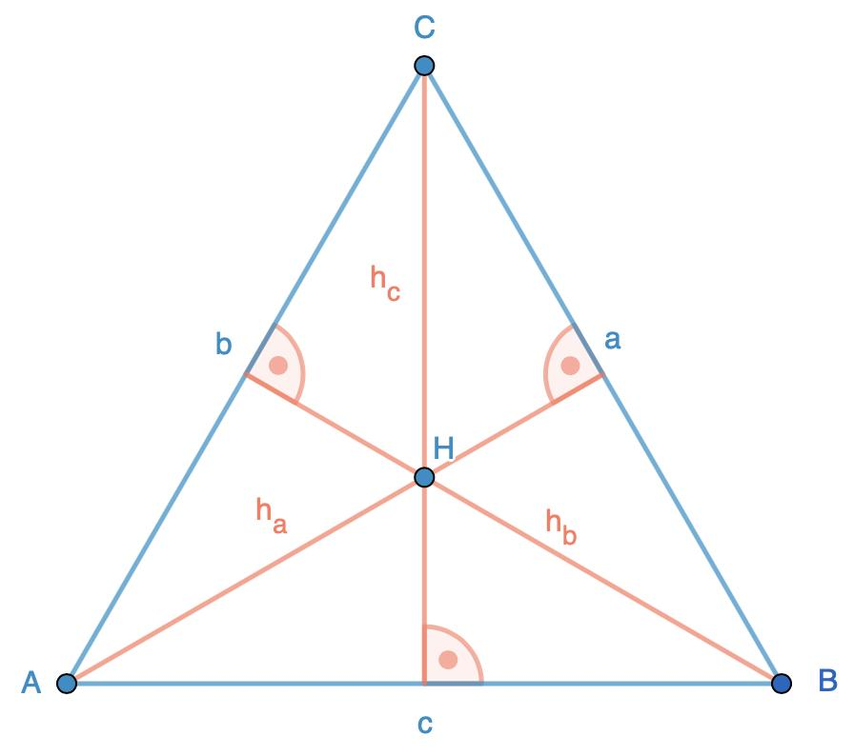
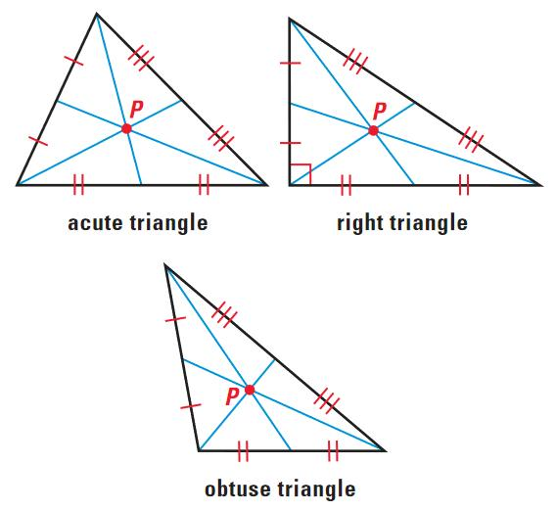
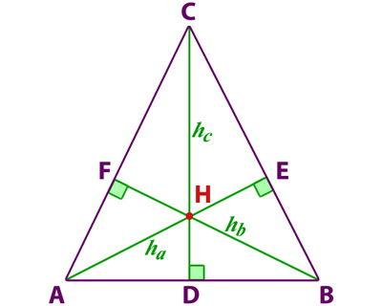
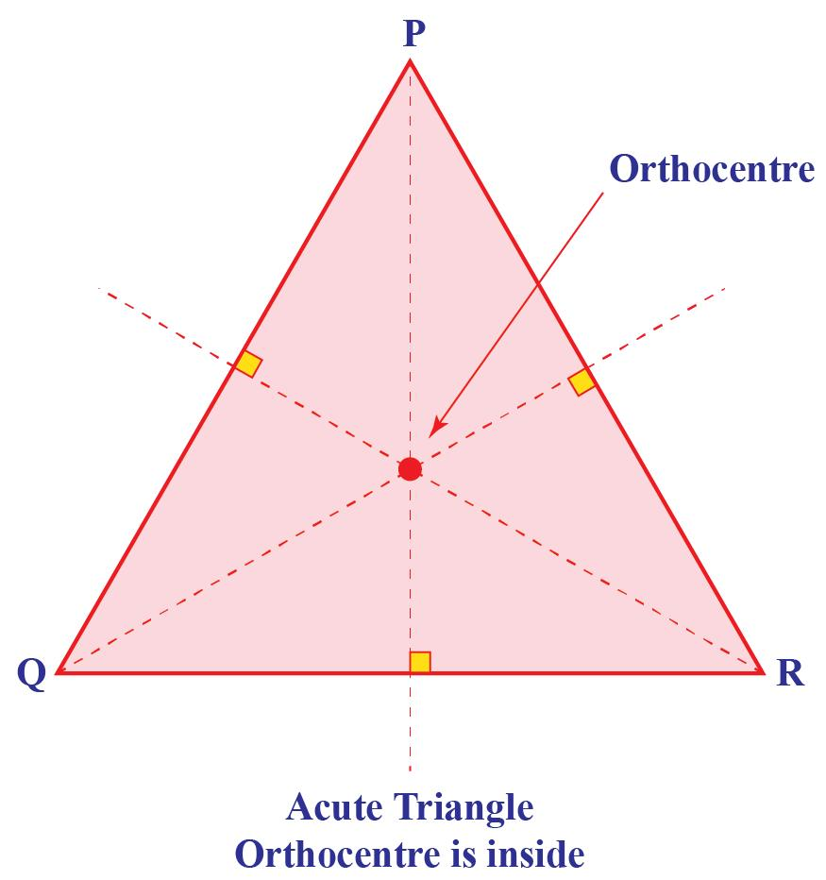

Purpose
# Source: AI Source: Provided by: [Data Path: Persons Table -> ID Column: 1, Name_En Column: Motasem Essam] -> From: [ChatGPT] on [7/25/2026]
The orthocenter is used to:
- Locate the common intersection of the three altitudes.
- Study perpendicular relationships in triangles.
- Solve problems involving altitudes and right angles.
- Analyze the location of triangle centers.
- Establish relationships between the orthocenter, circumcenter, and Euler line.
- Solve coordinate-geometry problems.

Fundamental Elements
# Source: AI Source: Provided by: [Data Path: Persons Table -> ID Column: 1, Name_En Column: Motasem Essam] -> From: [ChatGPT] on [7/25/2026]
For $△ABC$:
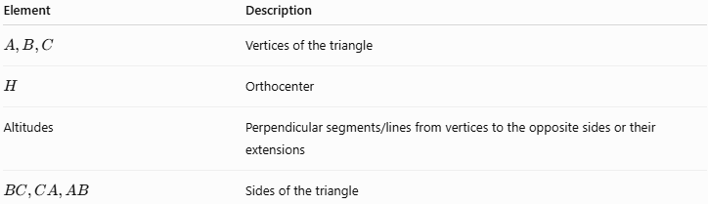
Element | Description
$$A,B,C$$ | Vertices of the triangle
$$H$$ | Orthocenter
Altitudes | Perpendicular segments/lines from vertices to the opposite sides or their extensions
$$BC,CA,AB$$ | Sides of the triangle
The defining relationship is:
$$\boxed{H=\text{intersection of the three altitudes}}$$

Altitude
# Source: AI Source: Provided by: [Data Path: Persons Table -> ID Column: 1, Name_En Column: Motasem Essam] -> From: [ChatGPT] on [7/25/2026]
An altitude of a triangle is a perpendicular segment or line drawn from a vertex to the line containing the opposite side.
For example, the altitude from $A$is perpendicular to $BC$:
$$\boxed{AD⊥BC}$$
where $D$lies on the line containing $BC$.
Similarly:
$$BE⊥AC$$
and:
$$CF⊥AB$$
These three altitudes intersect at $H$.

Orthocenter Theorem
# Source: AI Source: Provided by: [Data Path: Persons Table -> ID Column: 1, Name_En Column: Motasem Essam] -> From: [ChatGPT] on [7/25/2026]
The Orthocenter Theorem states:
The three altitudes of a nondegenerate triangle are concurrent at a single point called the orthocenter.
Therefore:
$$\boxed{AD∩BE∩CF=\left\{H\right\}}$$
where $AD$, $BE$, and $CF$are the three altitudes.
The word concurrent means that several lines or segments pass through the same point.

Perpendicular Relationships
If $H$is the orthocenter, then:
$$\boxed{AH⊥BC} \\ \boxed{BH⊥AC} \\ \boxed{CH⊥AB}$$
Therefore, the orthocenter is fundamentally associated with perpendicularity.
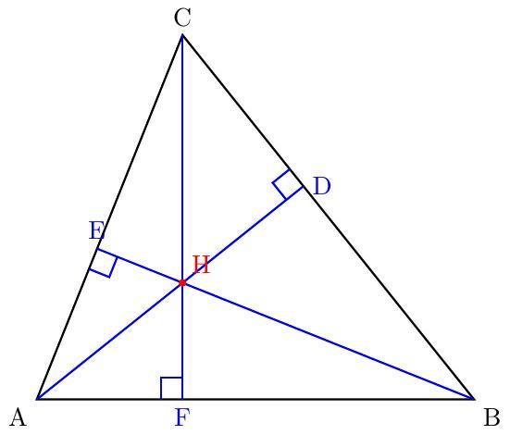
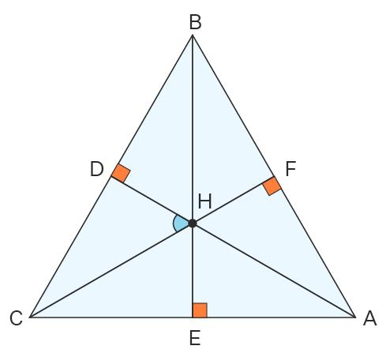
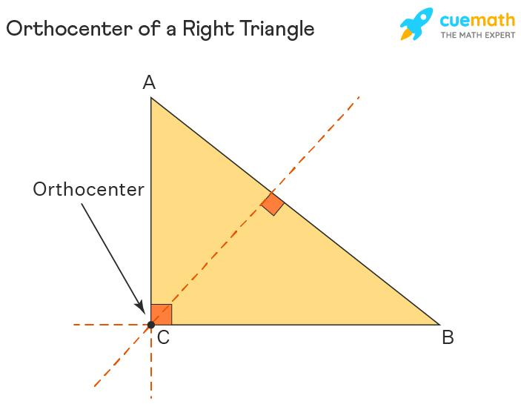
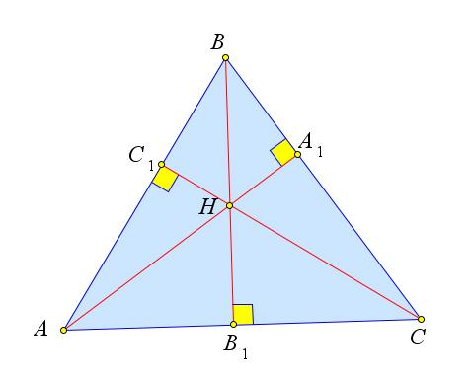

Location of the Orthocenter
# Source: AI Source: Provided by: [Data Path: Persons Table -> ID Column: 1, Name_En Column: Motasem Essam] -> From: [ChatGPT] on [7/25/2026]
The location of the orthocenter depends on the type of triangle.

Acute Triangle
# Source: AI Source: Provided by: [Data Path: Persons Table -> ID Column: 1, Name_En Column: Motasem Essam] -> From: [ChatGPT] on [7/25/2026]
In an acute triangle, all three altitudes intersect inside the triangle.
$$\boxed{H\text{ lies inside the triangle}}$$
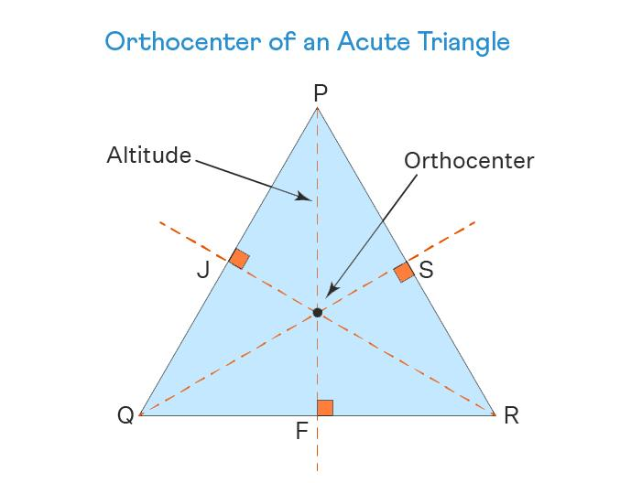
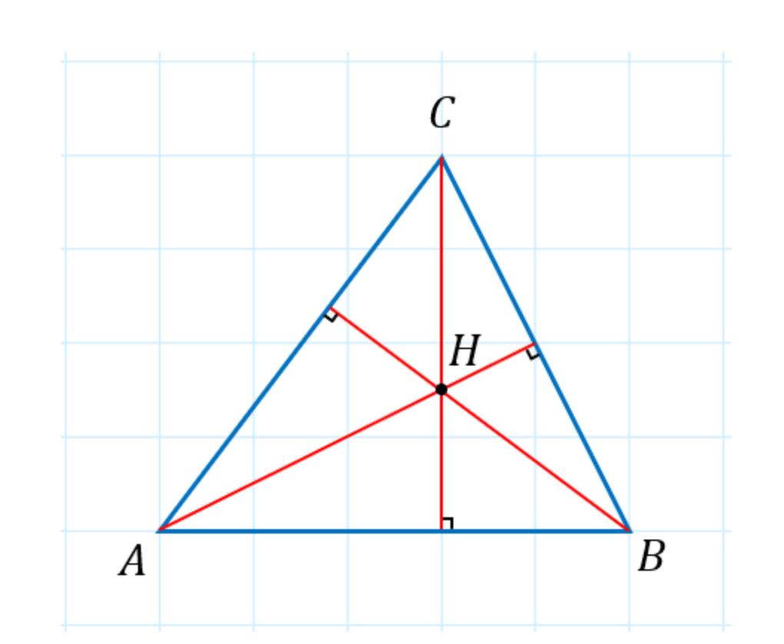
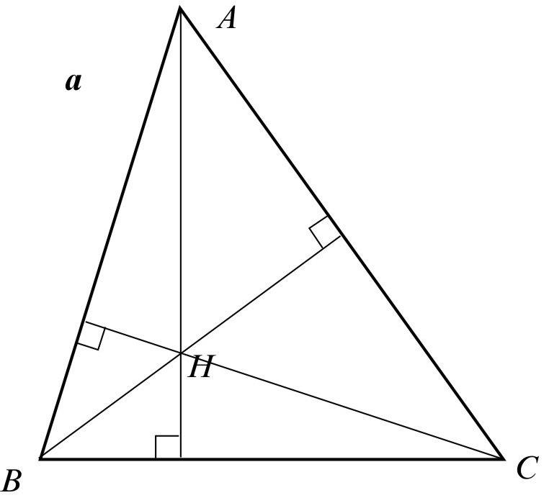

Right Triangle
# Source: AI Source: Provided by: [Data Path: Persons Table -> ID Column: 1, Name_En Column: Motasem Essam] -> From: [ChatGPT] on [7/25/2026]
In a right triangle, the orthocenter is located at the vertex of the right angle.
For example, if:
$$∠A={90}^{∘}$$
then:
$$\boxed{H=A}$$
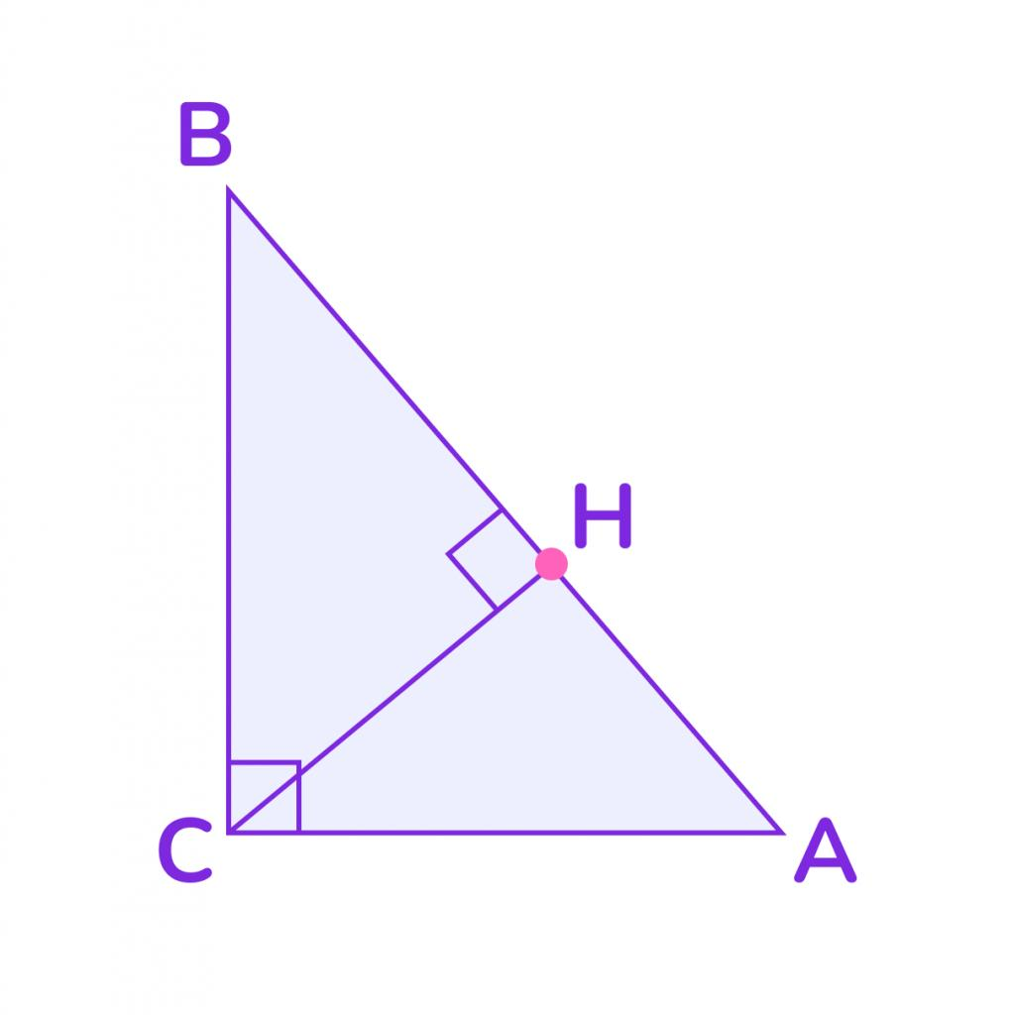
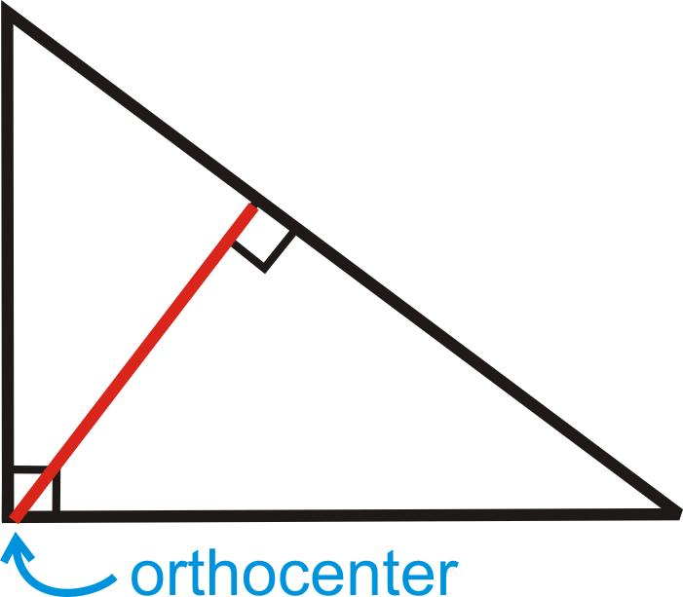
This occurs because the two legs themselves are already perpendicular to the opposite sides.

Obtuse Triangle
# Source: AI Source: Provided by: [Data Path: Persons Table -> ID Column: 1, Name_En Column: Motasem Essam] -> From: [ChatGPT] on [7/25/2026]
In an obtuse triangle, the orthocenter lies outside the triangle.
The altitudes from the acute-angle vertices meet the extensions of their opposite sides.
$$\boxed{H\text{ lies outside the triangle}}$$
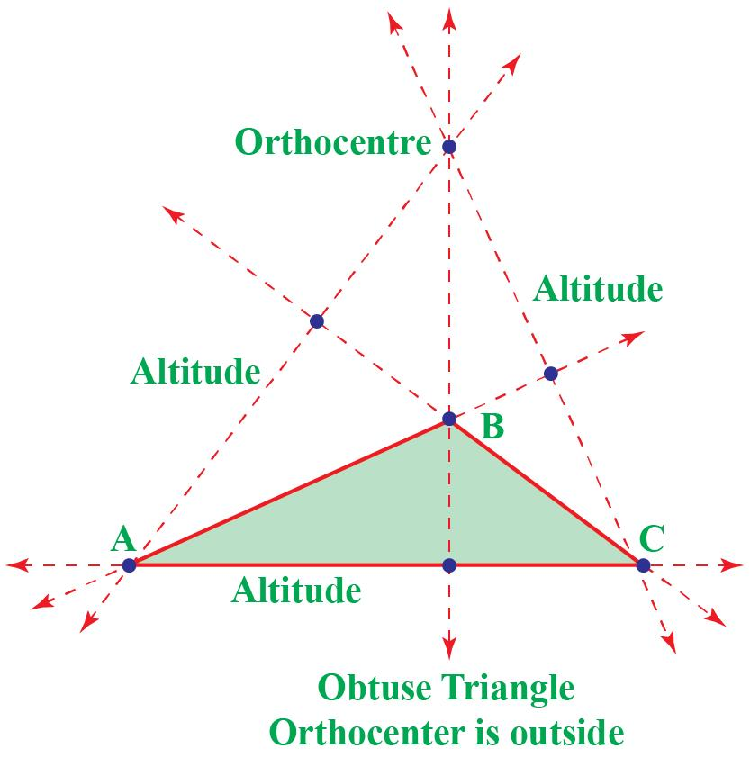
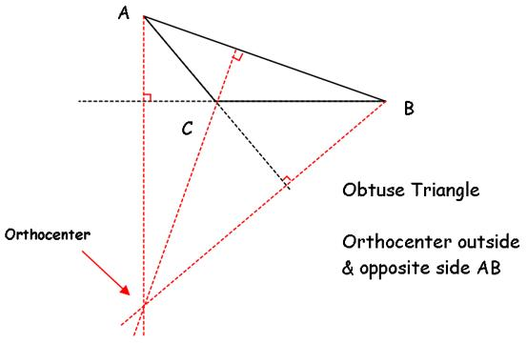
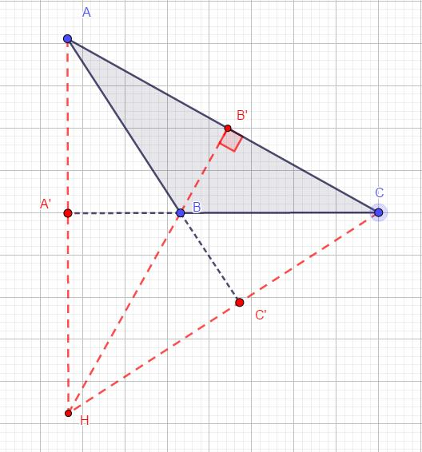
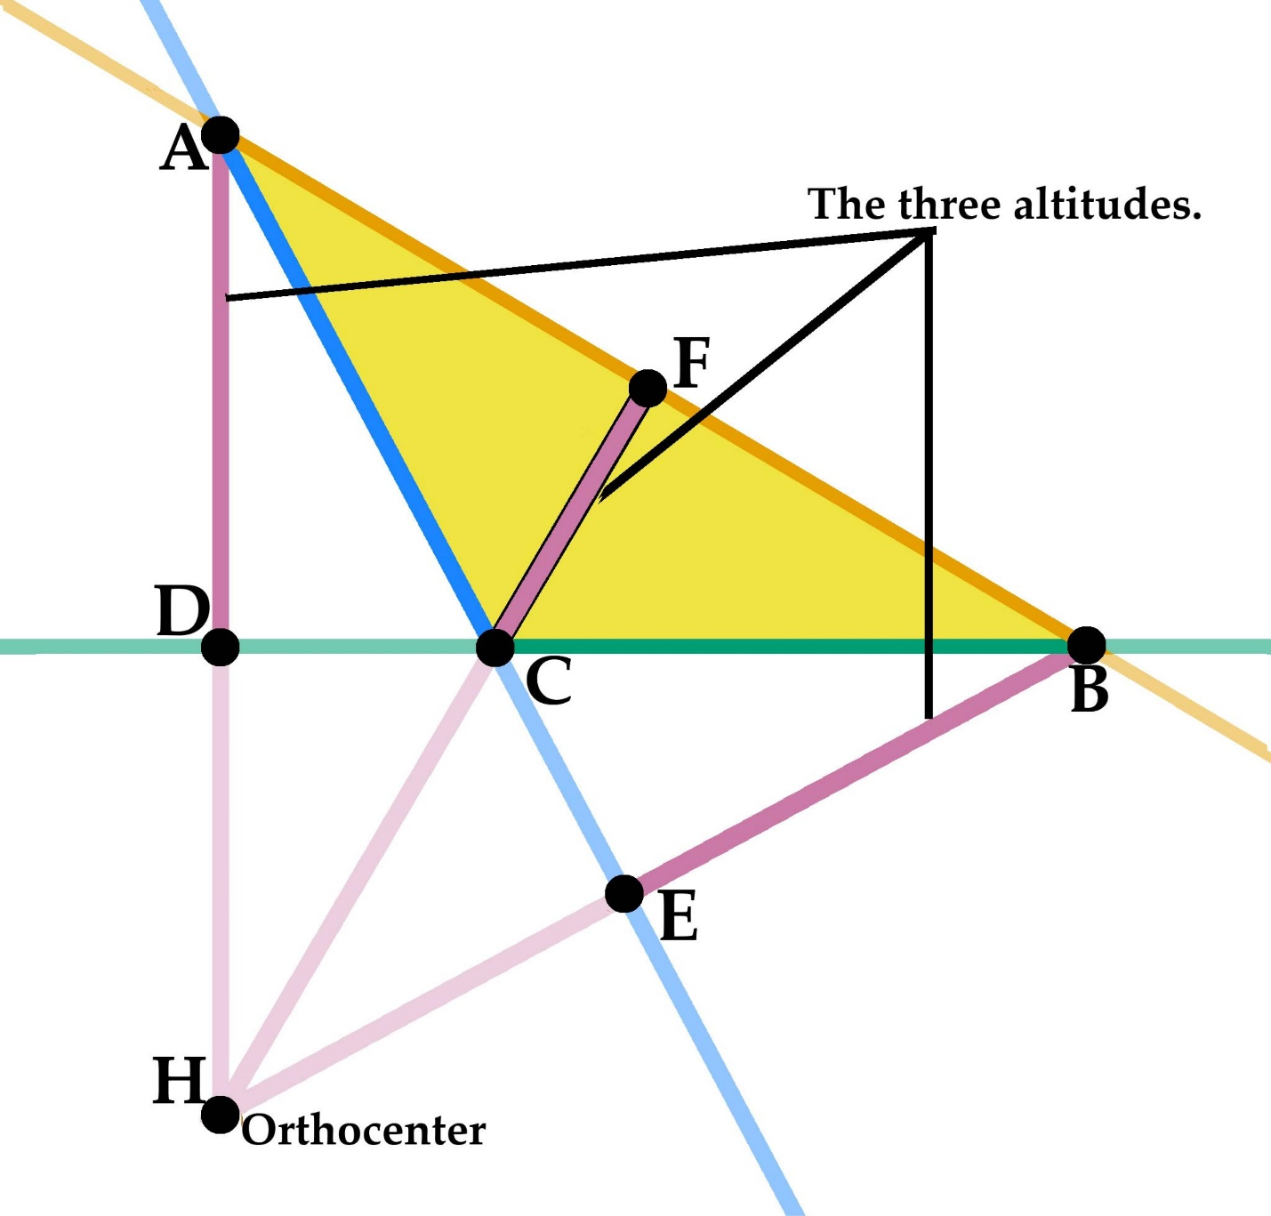

Summary of Orthocenter Location
# Source: AI Source: Provided by: [Data Path: Persons Table -> ID Column: 1, Name_En Column: Motasem Essam] -> From: [ChatGPT] on [7/25/2026]
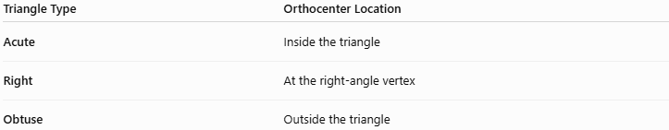
Triangle Type | Orthocenter Location
Acute | Inside the triangle
Right | At the right-angle vertex
Obtuse | Outside the triangle
This is similar to the circumcenter in that the location changes according to triangle type, but the specific rules are different.

Coordinate Geometry
# Source: AI Source: Provided by: [Data Path: Persons Table -> ID Column: 1, Name_En Column: Motasem Essam] -> From: [ChatGPT] on [7/25/2026]
The orthocenter can be found using the equations of two altitudes.
Suppose:
$$A=\left(x_{1} , y_{1}\right) \\ B=\left(x_{2} , y_{2}\right) \\ C=\left(x_{3} , y_{3}\right)$$
The altitude through $A$must be perpendicular to $BC$.
The altitude through $B$must be perpendicular to $AC$.
Solving the equations of these two altitudes gives:
$$\boxed{H=\left(x_{H} , y_{H}\right)}$$
The third altitude will automatically pass through the same point.

Example: Orthocenter of a Right Triangle
# Source: AI Source: Provided by: [Data Path: Persons Table -> ID Column: 1, Name_En Column: Motasem Essam] -> From: [ChatGPT] on [7/25/2026]
Consider:
$$A=\left(0 , 0\right) \\ B=\left(6 , 0\right) \\ C=\left(0 , 8\right)$$
Since:
$$AB⊥AC$$
we have:
$$∠A={90}^{∘}$$
Therefore, the orthocenter is the right-angle vertex:
$$\boxed{H=\left(0 , 0\right)}$$

Example: Orthocenter Using Altitudes
# Source: AI Source: Provided by: [Data Path: Persons Table -> ID Column: 1, Name_En Column: Motasem Essam] -> From: [ChatGPT] on [7/25/2026]
Consider:
$$A=\left(0 , 4\right), B=\left(0 , 0\right), C=\left(6 , 0\right)$$
The side $BC$is horizontal, so the altitude from $A$is vertical:
$$x=0$$
The slope of $AC$is:
$$m_{AC}=\frac{0-4}{6-0}=-\frac{2}{3}$$
Therefore, the altitude from $B$, being perpendicular to $AC$, has slope:
$$m=\frac{3}{2}$$
Its equation through $B=\left(0 , 0\right)$is:
$$y=\frac{3}{2}x$$
Intersecting with:
$$x=0$$
gives:
$$y=0$$
Therefore:
$$\boxed{H=\left(0 , 0\right)}$$

Orthocenter and Circumcircle
# Source: AI Source: Provided by: [Data Path: Persons Table -> ID Column: 1, Name_En Column: Motasem Essam] -> From: [ChatGPT] on [7/25/2026]
The orthocenter has an important relationship with the circumcircle.
For a triangle inscribed in a circle, the three altitudes intersect at the orthocenter.
There are also several important relationships involving the orthocenter and the circumcircle, including the Euler line.

Orthocenter and Euler Line
# Source: AI Source: Provided by: [Data Path: Persons Table -> ID Column: 1, Name_En Column: Motasem Essam] -> From: [ChatGPT] on [7/25/2026]
For a general triangle, three important centers lie on a common line called the Euler line:
$$\boxed{O, G, H}$$
where:
- $O$= circumcenter
- $G$= centroid
- $H$= orthocenter
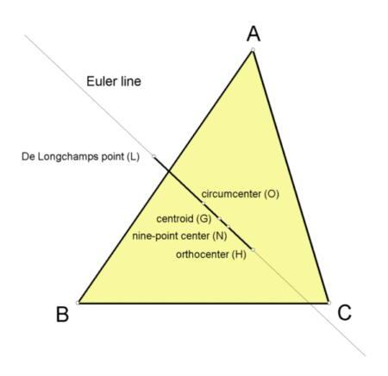
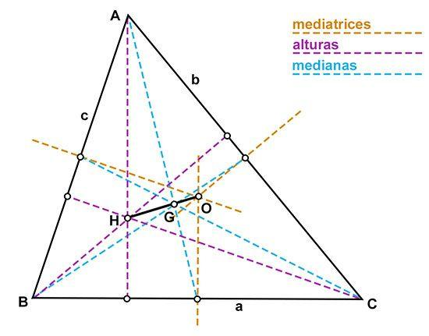
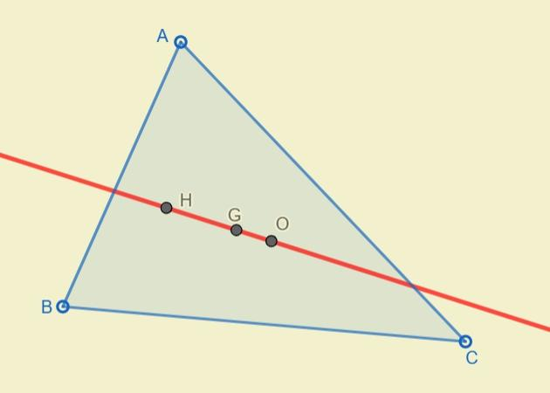
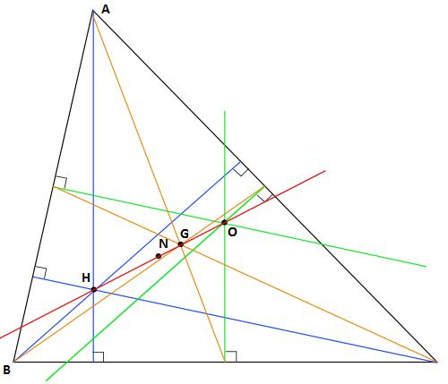
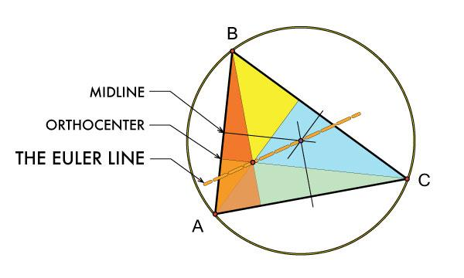
The centroid divides the segment joining the circumcenter and orthocenter in a fixed ratio:
$$\boxed{OG:GH=1:2}$$
Equivalently:
$$\boxed{OH=3OG}$$
for a non-equilateral triangle.

Special Case: Equilateral Triangle
# Source: AI Source: Provided by: [Data Path: Persons Table -> ID Column: 1, Name_En Column: Motasem Essam] -> From: [ChatGPT] on [7/25/2026]
In an equilateral triangle, the principal triangle centers coincide.
Therefore:
$$\boxed{G=I=O=H}$$
The centroid, incenter, circumcenter, and orthocenter are all the same point.
Consequently, the Euler line is not uniquely determined because all of these centers occupy the same point.

Orthocenter and Altitudes
# Source: AI Source: Provided by: [Data Path: Persons Table -> ID Column: 1, Name_En Column: Motasem Essam] -> From: [ChatGPT] on [7/25/2026]
The relationship can be summarized as:
$$\boxed{\text{Three Altitudes}⟶\text{Orthocenter}}$$
Specifically:
$$AH⊥BC \\ BH⊥AC \\ CH⊥AB$$

Orthocenter vs Centroid
# Source: AI Source: Provided by: [Data Path: Persons Table -> ID Column: 1, Name_En Column: Motasem Essam] -> From: [ChatGPT] on [7/25/2026]
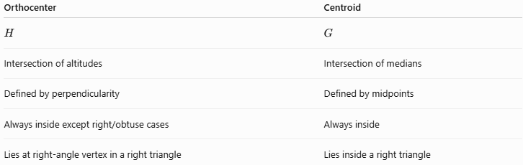
Orthocenter | Centroid
$$H$$ | $$G$$
Intersection of altitudes | Intersection of medians
Defined by perpendicularity | Defined by midpoints
Always inside except right/obtuse cases | Always inside
Lies at right-angle vertex in a right triangle | Lies inside a right triangle

Orthocenter vs Incenter
# Source: AI Source: Provided by: [Data Path: Persons Table -> ID Column: 1, Name_En Column: Motasem Essam] -> From: [ChatGPT] on [7/25/2026]
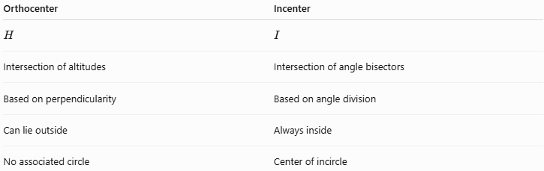
Orthocenter | Incenter
$$H$$ | $$I$$
Intersection of altitudes | Intersection of angle bisectors
Based on perpendicularity | Based on angle division
Can lie outside | Always inside
No associated circle | Center of incircle

+Orthocenter vs Circumcenter
# Source: AI Source: Provided by: [Data Path: Persons Table -> ID Column: 1, Name_En Column: Motasem Essam] -> From: [ChatGPT] on [7/25/2026]
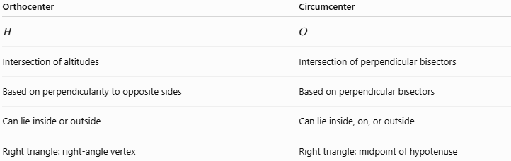
Orthocenter | Circumcenter
$$H$$ | $$O$$
Intersection of altitudes | Intersection of perpendicular bisectors
Based on perpendicularity to opposite sides | Based on perpendicular bisectors
Can lie inside or outside | Can lie inside, on, or outside
Right triangle: right-angle vertex | Right triangle: midpoint of hypotenuse

Four Principal Triangle Centers
# Source: AI Source: Provided by: [Data Path: Persons Table -> ID Column: 1, Name_En Column: Motasem Essam] -> From: [ChatGPT] on [7/25/2026]
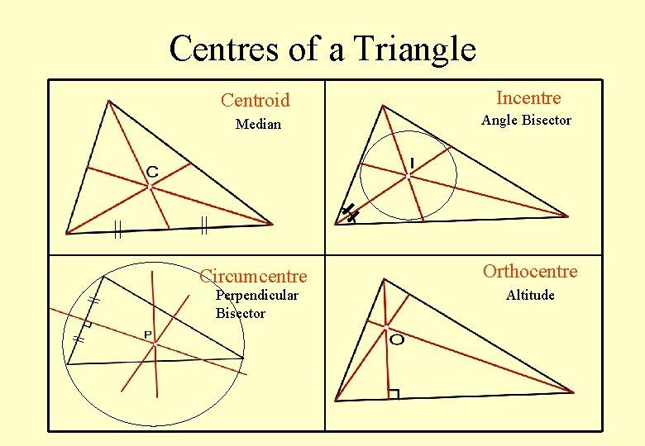
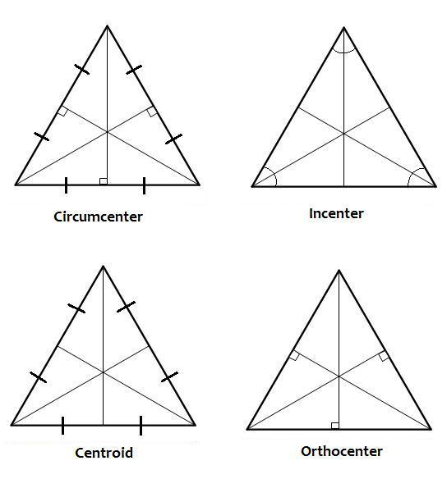
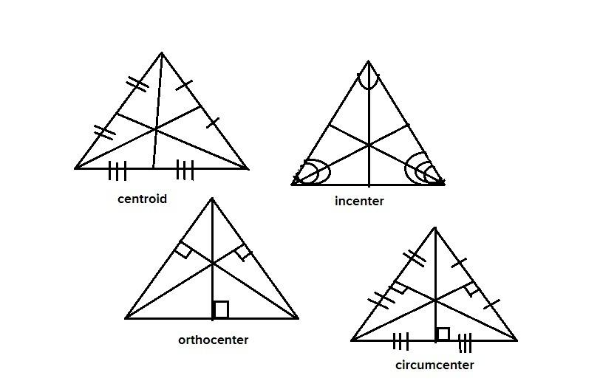
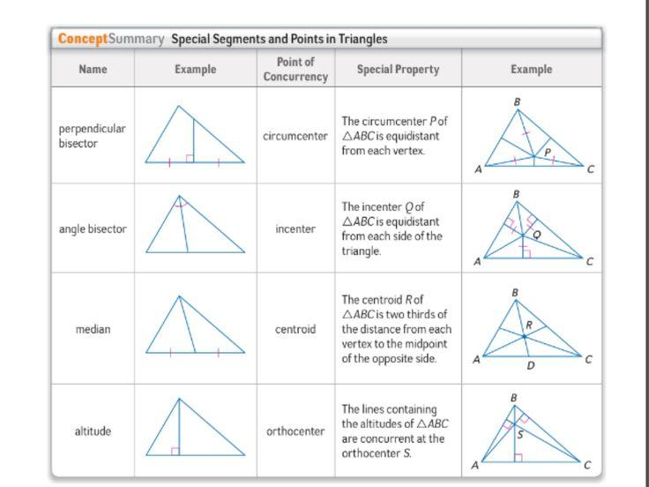
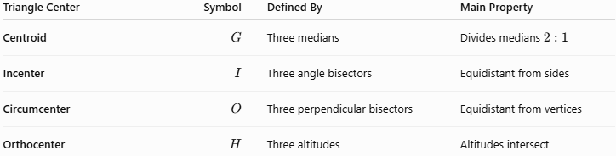
Triangle Center | Symbol | Defined By | Main Property
Centroid | $$G$$ | Three medians | Divides medians $2:1$
Incenter | $$I$$ | Three angle bisectors | Equidistant from sides
Circumcenter | $$O$$ | Three perpendicular bisectors | Equidistant from vertices
Orthocenter | $$H$$ | Three altitudes | Altitudes intersect

Important Properties
# Source: AI Source: Provided by: [Data Path: Persons Table -> ID Column: 1, Name_En Column: Motasem Essam] -> From: [ChatGPT] on [7/25/2026]
- Every nondegenerate triangle has exactly one orthocenter.
- The orthocenter is the intersection of the three altitudes.
- The three altitudes are concurrent.
- Each altitude is perpendicular to the line containing its opposite side.
- In an acute triangle, the orthocenter lies inside.
- In a right triangle, the orthocenter is the right-angle vertex.
- In an obtuse triangle, the orthocenter lies outside.
- The orthocenter, centroid, and circumcenter generally lie on the Euler line.
- In an equilateral triangle:
$$\boxed{G=I=O=H}$$

Related Concepts
# Source: AI Source: Provided by: [Data Path: Persons Table -> ID Column: 1, Name_En Column: Motasem Essam] -> From: [ChatGPT] on [7/25/2026]
The orthocenter is directly related to:
- Altitude
- Perpendicular Lines
- Right Angles
- Concurrent Lines
- Circumcenter
- Circumcircle
- Centroid
- Euler Line
- Orthic Triangle
- Triangle Centers

Key Formula Summary
# Source: AI Source: Provided by: [Data Path: Persons Table -> ID Column: 1, Name_En Column: Motasem Essam] -> From: [ChatGPT] on [7/25/2026]
Orthocenter definition
$$\boxed{H=\text{intersection of the three altitudes}}$$
Altitude relationships
$$\boxed{AH⊥BC} \\ \boxed{BH⊥AC} \\ \boxed{CH⊥AB}$$
Euler line relationship
$$\boxed{O, G, H\text{ are collinear}}$$
and, for a non-equilateral triangle:
$$\boxed{OG:GH=1:2}$$

Conclusion
# Source: AI Source: Provided by: [Data Path: Persons Table -> ID Column: 1, Name_En Column: Motasem Essam] -> From: [ChatGPT] on [7/25/2026]
The Triangle Orthocenter is the unique point where the three altitudes of a triangle intersect. It is fundamentally defined by perpendicularity and concurrency.
Its most important relationships are:
$$\boxed{H=\text{intersection of the three altitudes}} \\ \boxed{AH⊥BC, BH⊥AC, CH⊥AB}$$
Its position depends on the triangle type:
$$\boxed{\begin{matrix}\text{Triangle} & \text{Orthocenter Location} \\ \text{Acute} & \text{Inside} \\ \text{Right} & \text{Right-angle vertex} \\ \text{Obtuse} & \text{Outside}\end{matrix}}$$
The orthocenter completes the four principal classical triangle centers alongside the centroid, incenter, and circumcenter.

